Create Your Vision Map Using Mind Mapping

What Is Mind Mapping?

Mind mapping is a whole-brain tool that allows you to use your brain more effectively and efficiently. It is a method of using pictures, colors, and keywords to help you organize your thoughts and execute your vision.
Whether you use mind mapping for personal or professional reasons, I believe it will make a difference in your organizational and communication skills.

Are you ready to explore the possibilities that will lead to a more fulfilling life?

Review the vision map template, then create your own.
Answer the questions and record them on your map:
- What motivates you?
  - Is it receiving awards and certificates?
  - Is it creating something?
  - Is it helping others?

- What are your guiding principles?
  - Is it alone time? Is it important to have time to reflect?
  - Is it family time?
  - Is it living with integrity and being true to yourself?
  - Is it your spirituality?

- Who do you admire and why? What characteristics do your heroes and sheroes have?

- What legacy do you want to leave behind? What do you want people to say about you?

- What are your strengths and weaknesses?

Vision Mind Map
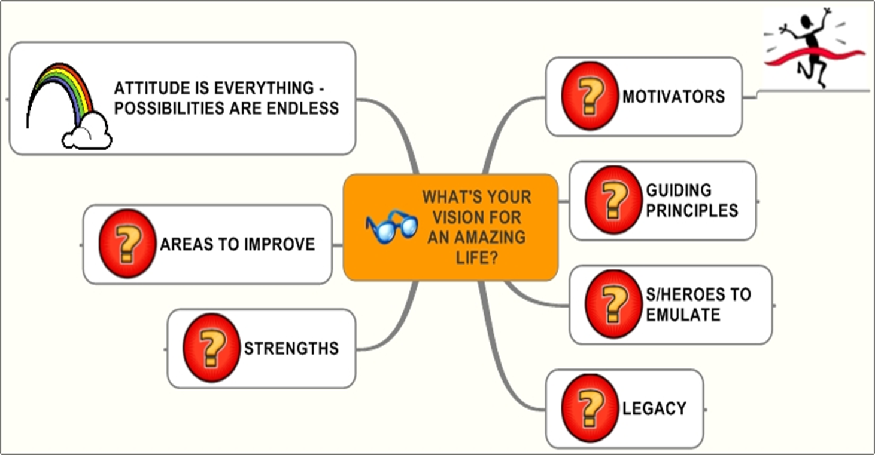

- On a separate sheet of paper, create your vision map.
- Review it daily
- Take action

- If you have questions, contact Lisa Harvey Roach at Lisa@LisaHarveyRoach.com

